Processing approval plans with In-Process records

Vendors : Iberoamericana, Ana Maria Martinez, Libros Andinos, Harrassowitz, Lexicon
These vendors supply us with brief in-process records which we load into Voyager. The object is to receive the books and create item records and send them forward to ACCT for searching, cataloging or sending to the hold. There are no judgments to be made on the quality of the records.
Note that articles in Spanish are “El”, “La”, “Los”, “Las”, “Un”, “Una”. German articles are Die, Der. Skip over these words at the beginning of a title when doing a title (Bib) search to bring up the record.
Settings
Initial steps are the same as you do with other approval plans : Be sure your preferences and optons in the cataloging module are set according to standard procedure. When you log into Cataloging: Click on the magnifying glass (search) icon Search for Title(Bib)"1/2 hour". When the record for "1/2 hour special handling" comes up, click on the Boat icon to save the record.
Search the first title on the invoice and use the link from the catalog record to the purchase order in Acquisitions Write down the vendor code and PO number from the order. Also check the fund number and location on the order.
Always be sure you are looking at a record from the correct vendor. (see samples at end of instructions). Also, when you bring up the bibliographic display, check the hierarchy display . It should say “In the pre-order process” and should have the same location as the PO number for the invoice.

Procedure
1. Search by title to find the record for the book
3. Use win-alt-n to run the macro on the bib record. When you are at the holdings record, change location if necessary.
4. Run the win-alt-n macro. Wand the barcode into the item record and hit the enter key. Click on the Print button in the pop-up window to print a receipt slip. The barcode should be attached to the book using standard procedure : Front cover for hardcover and rcppa books, taped inside the cover for paperbacks.
6. Write the fund number and PO number in the gutter of the book.
7. Books should be delivered to the non-member copy truck in Tom’s unit when done.
8. Set aside duplicates or other problems to review with Debbie

Booksets : write on the slip “NH-Set”. Should be delivered to the same truck.

SAMPLES
Harrassowitz record - See 910 message, and “har” in the 981 field. The invoice number is in 980 field, subfield f.
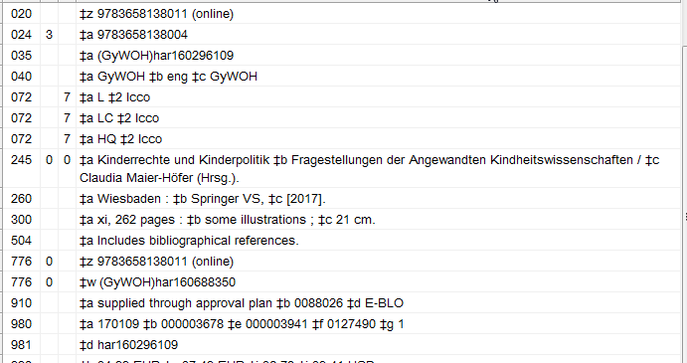

Iberoamericana record – See ES-MalEV in 035, 040
Invoice number is in 980 field, subfield f
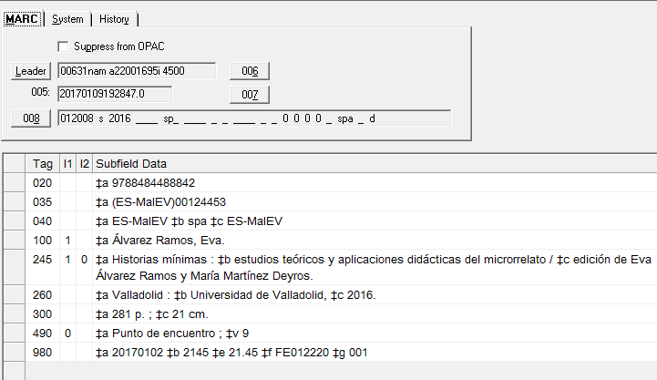

Libros Andinos record – BOCbLA in the 040 field

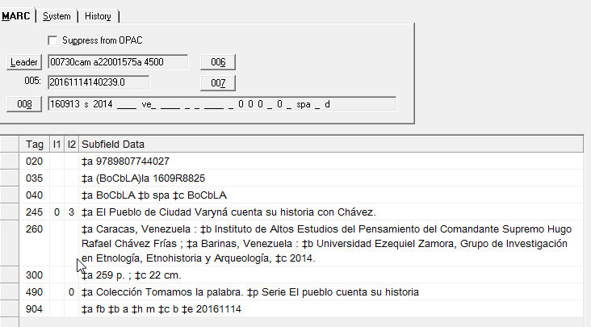

Libros Argentinos (Ana Maria Martinez) – LibArg in 040

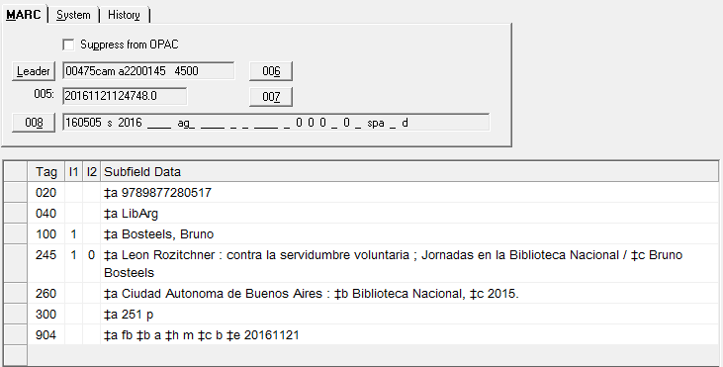

Lexicon - PIWaKWL in 035, 040
